A COMPREHENSIVE ANALYSIS OF FINANCIAL PERFORMANCE: INSIGHTS FROM LEADING BANKS

1 INTRODUCTION

Banks play an important role in the financial system and the economy. As a key component of the financial system, banks allocate funds from savers to borrowers in an efficient manner. They provide specialized financial services, which reduce the cost of obtaining information about both savings and borrowing opportunities. These financial services help to make the overall economy more efficient.

OVERVIEW

Our project mainly focuses on the assets of the bank from all over the world by which we analysed to get a pictorial representation of top banks and we also classified them on basis of region and country and continent wise, here we used tableau for the representation of data and SQL for the database. Our team member indulge into the project and their valuable input help to made the data more beautiful and in eloquent way and though we have small set of data we have held up to utilize it in every possible way.

we have given our maximum effort in making the visualization unique and uncomparable and last we have integrated our template into the dashboard of website which we got using bootstrap and deployed our makings there.

PURPOSE

In the recent decade we are encountering a tremenderous change in the way we handle money before it had been in physical and people had great hassel of safe guarding it form theft and other form of natural disaster. But the rapid growth of technogly has wiped the use of physical money any more so which directly makes us to visit to the bank. Therefore selecting a best bank to keep our money was tedious one. Financial sector is the backbone and the fInancial performance of banks has implications for economic growth of any country. The evaluation of fInancial performance of banks in any countries important today because of the ferce competition and is expected to help management, regulators, policy makers, shareholders and other stakeholders. Further, it is great of importance for the resource providers for making correct investment decisions. So good fInancial performance rewards the shareholders for their investment and even encourages additional investment and brings about economic growth. On the other hand, poor banking performance can lead to banking failure and crisis which have negative impact on the economic growth. In globalization, both private and public banks are operating and expanding their branches in the various parts of world, the eFfciency of the banking system has been one of the major issues in the new monetary and fInancial environment. Hence, in this project we have imperatively analysis the fInancial performance of banks in different countries in terms of rank and total assets. For that, we have utilized Tableau to take and provide the insights of data in terms of visualizations and Dashboard

2 Problem Definition & Design Thinking

Empathy Map

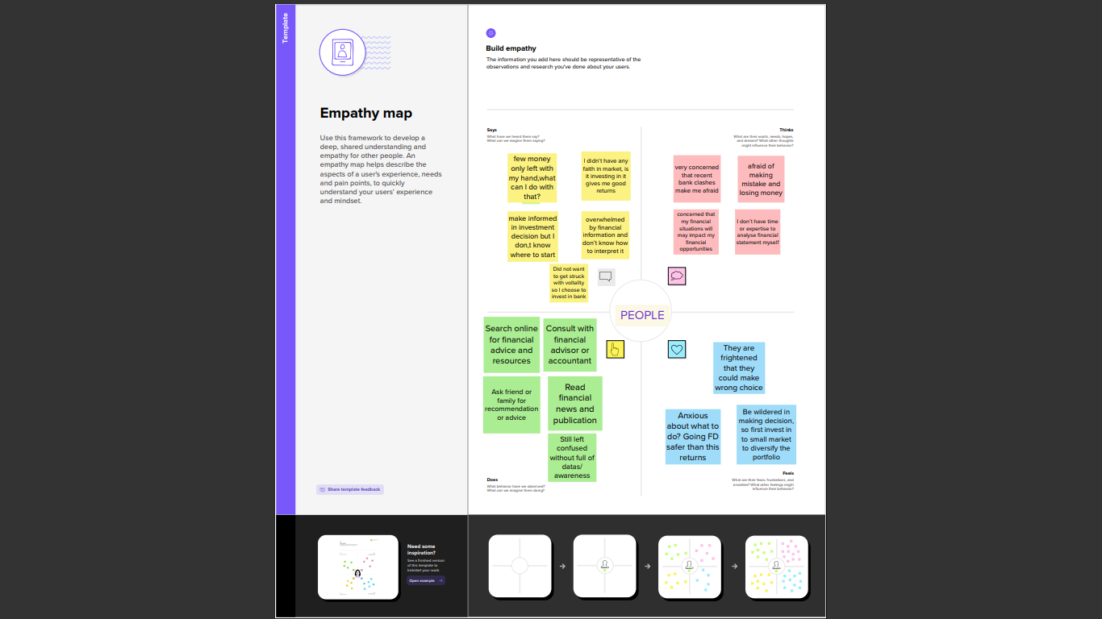

BRAINSTROMING

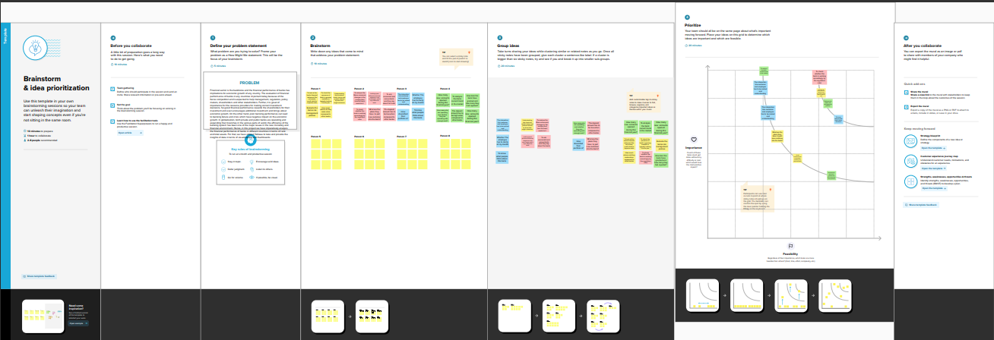

3 RESULT

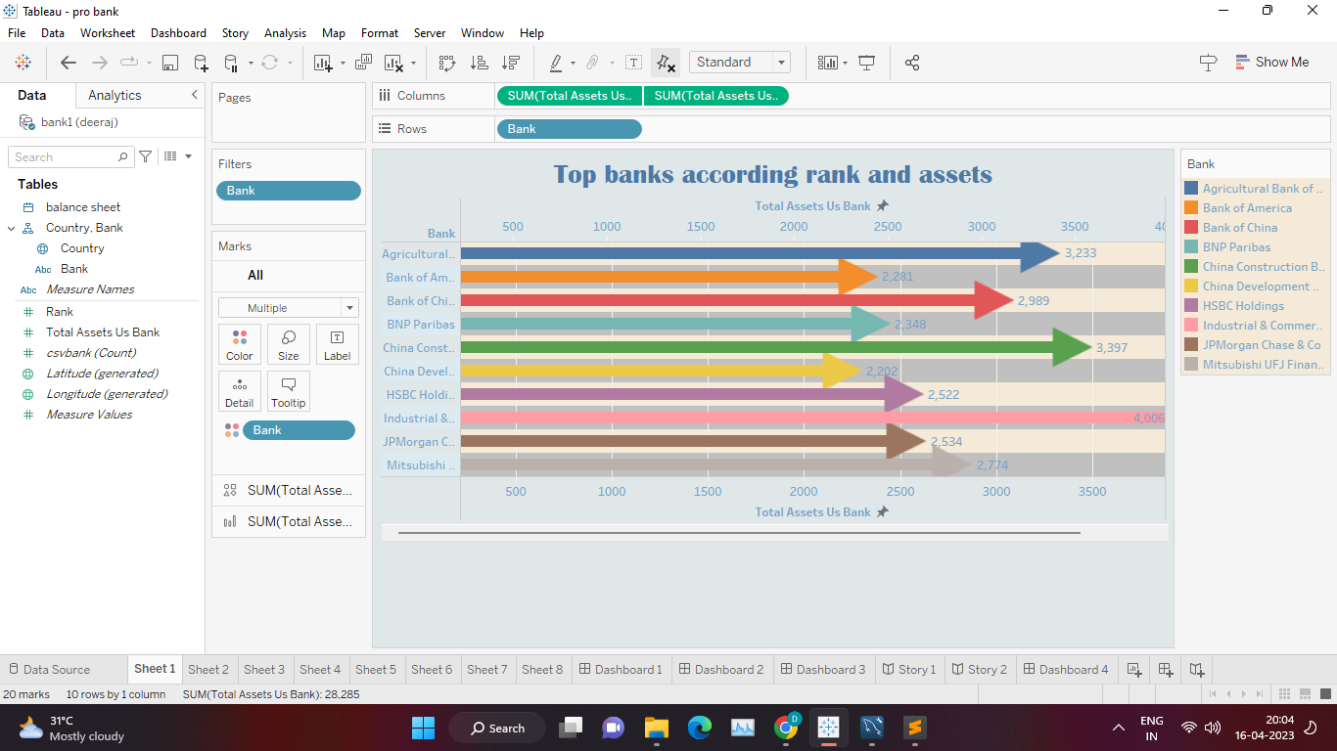

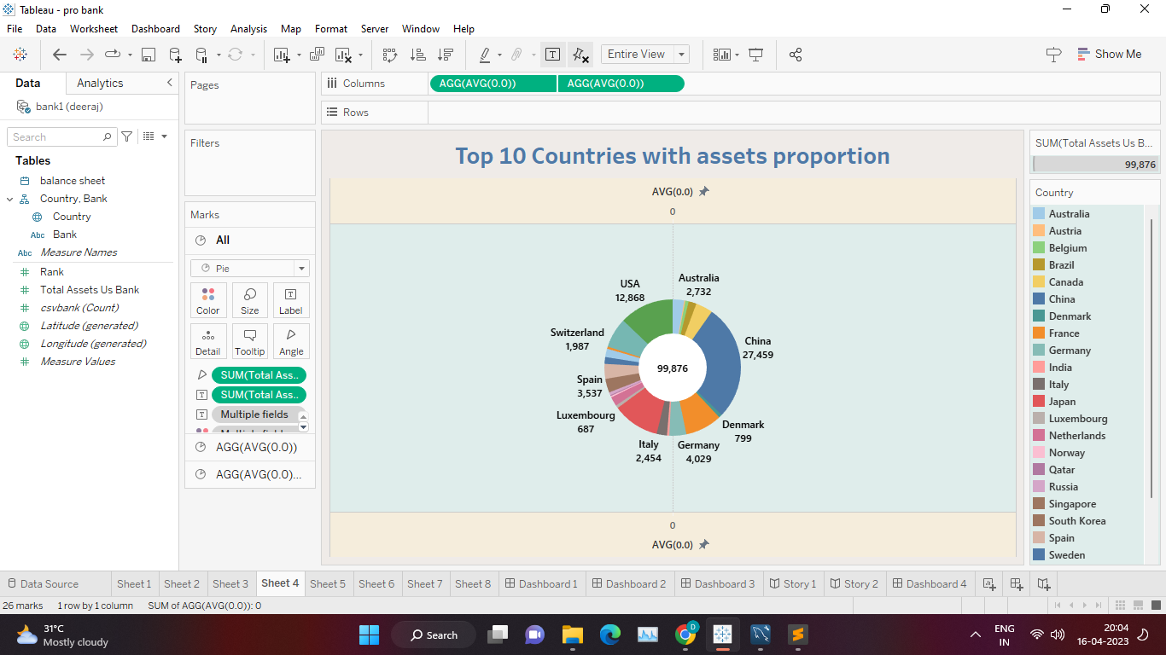

3 ADVANTAGES & DISADVANTAGES

ADVANTAGES

* Banks are the safest instrument to keep our money and top banks 10 are the most safest place to keep our
* Knowing top 10 bank in the world would help us in many like if we some where in the earth surely there will be branch of the particular bank.
* Bank may also help us to transfer money all over the world without any time lag.
* Banks acts as intermediate between investor and the borrower so the top 10 bank in the world would also act as intermediate and the transaction happen over the countries this help for the growth of economy.
* Large industries can be created if the top 10 bank in the world lend money to them to lay the industries all over the world.
* Large banks are also involved in various activities like donating to the poor nations in the world they also help them to open bank account to make them adapt with the current world trend. They also collect money from various organisation and donate them on poor nation for its development on infrastructure and education.

Disadvantage

* It may reduce the competition new banks cannot operate if there is no costumer to them.
* Focusing only on the top 10 banks in the world may lead to a limited understanding of the financial industry, as there are thousands of banks and financial institutions around the world, each with unique advantages and disadvantages.
* The ranking of top banks may vary depending on the criteria used, and it can be difficult to compare banks in different countries and regions This may or may not lead to biased data in.
* Relying solely on the top 10 banks for financial services risks concentration, leaving you vulnerable to the failure or downturn of these institutions
* Knowing only the top 10 banks can lead to over-reliance on these institutions for financial services, limiting your options and potentially have caused you to lose results or incur high costs.
* Dynamic Nature: The rankings of major funds can change rapidly due to market conditions, mergers, or other factors, so information can quickly become out of date It is important to stay abreast of the latest developments in the economy.

5 APPLICATION

* Get to know the top banks and get an idea of ​​the institutions that have the biggest impact on the global economy and financial system. This understanding can be useful in making sound investment decisions, especially if you are interested in investing
* Many of the world’s largest banks are located around the world, knowing who they are can help you identify banks that have branches or subsidiaries in your country This knowledge can be particularly useful if you apply to access financial services such as savings, loans with and inputs.
* If you're interested in working in finance, knowing the top banks can help identify potential candidates and job opportunities and let you know what skills and experiences are in high demand at financially well understood.
* If you travel abroad frequently, knowing the top banks can help you find which organizations have ATM branches in the countries you visit. This knowledge can help you avoid high fees and easily access cash or financial services.
* Generally, the world’s largest banks are well established and have a strong reputation for stability and reliability. If you are looking to open a bank account or invest in a fund, identifying stable and reputable banks can help you make an informed decision.

6 CONCLUSION

At last we are more concerned about Top 10 bank in the world which helps us in various ways. More or less the aim of our project was completely fulfilled with the use of tableau and mysql. And we successfully coordinated with each other in our team and our team member idea helped this project to get on to the next level than we expected. There is lots of conundrum at the initial stage which make us to think a lot and helped us to do this. Finally, we have came to know how prepare visualize data in various form using tableau and I firmly believe that this would help us to get a good job.

7 FUTURE SCOPE

* Looking at the revenue and profit figures of the top 10 banks can provide valuable insights into their business model, profitability and growth potential It can also help identify areas with strengths and weaknesses, such as revenue inefficiencies or costs Those who eat profits.
* Analyzing the market share of each of the top ten banks in their respective industries can help identify incumbents and potential competitors. It can also provide an overview of the competitive landscape in the economy, highlighting potential areas of opportunity or disadvantage.
* An analysis of the customer demographics of each of the top 10 banks can help identify their customer demographics, product and service preferences, and satisfaction levels This can help identify areas for improvement and opportunities developments, such as new products or services that may be required.
* A risk assessment of the top 10 banks can help identify potential risk factors, such as exposure to specific industries or geographic areas, and assess risk management practices effectiveness can also help identify opportunities for improvement, such as the effective use of risk management tools or practices.
* Looking at the digital transformation efforts of the top 10 banks can provide insights into their strategies for innovation, customer engagement and operational efficiency. It can also help identify areas where technology can be used to develop new products and services, improve customer experience and streamline processes.
* The financial statements of the top 10 banks provide a wealth of information for data analysis, including balance sheets, income statements and cash flow statements They can be created with these documents basic financial metrics such as return on assets, return on investment and efficiency metrics.
* Regulatory filings such as annual reports, 10-Ks, and 10-Qs provide detailed information about the top 10 banks’ performance, risk management, and financial performance . . . . This information can be used for comparative analysis, benchmarking and trend analysis.
* Research and reporting by industry associations, consulting firms and research organizations can provide valuable insights into trends and issues affecting the top ten banks. These reports can cover topics such as customer satisfaction, digital transformation, risk management and regulatory compliance.
* News and media articles provide information about the latest developments and events affecting the top ten banks. This information can be used to monitor market sentiment, identify trends, and assess the impact of current events on the financial industry.
* Social media platforms can be used to gather insights into customer sentiment, engagement and preferences of the top ten banks. This information can be used to inform marketing strategies, product development, and customer service initiatives.

8 APPENDIX

Source Code

<!DOCTYPE html>

<html lang="en">

<head>

<meta charset="utf-8">

<meta content="width=device-width, initial-scale=1.0" name="viewport">

<title>FIN TECH Bootstrap Template</title>

<meta content="" name="description">

<meta content="" name="keywords">

<!-- Facebook Opengraph integration: https://developers.facebook.com/docs/sharing/opengraph -->

<meta property="og:title" content="">

<meta property="og:image" content="">

<meta property="og:url" content="">

<meta property="og:site_name" content="">

<meta property="og:description" content="">

<!-- Twitter Cards integration: https://dev.twitter.com/cards/ -->

<meta name="twitter:card" content="summary">

<meta name="twitter:site" content="">

<meta name="twitter:title" content="">

<meta name="twitter:description" content="">

<meta name="twitter:image" content="">

<!-- Favicons -->

<link href="assets/img/favicon.png" rel="icon">

<link href="assets/img/apple-touch-icon.png" rel="apple-touch-icon">

<!-- Google Fonts -->

<link href="https://fonts.googleapis.com/css?family=Raleway:400,500,700|Roboto:400,900" rel="stylesheet">

<!-- Vendor CSS Files -->

<link href="assets/vendor/bootstrap/css/bootstrap.min.css" rel="stylesheet">

<link href="assets/vendor/bootstrap-icons/bootstrap-icons.css" rel="stylesheet">

<link href="assets/vendor/glightbox/css/glightbox.min.css" rel="stylesheet">

<!-- Template Main CSS File -->

<link href="assets/css/style.css" rel="stylesheet">

<!-- =======================================================

* Template Name: FIN TECH

* Updated: Mar 09 2023 with Bootstrap v5.2.3

* Template URL: https://bootstrapmade.com/FIN TECH-free-bootstrap-4-template/

* Author: BootstrapMade.com

* License: https://bootstrapmade.com/license/

======================================================== -->

</head>

<body>

<!-- ======= Hero Section ======= -->

<section id="hero" class="hero">

<div class="container text-center">

<div class="row">

<div class="col-md-12">

<a class="hero-brand" href="index.html" title="Home"><img alt="FIN TECH Logo" src="assets/img/logo.png"></a>

</div>

</div>

<div class="col-md-12">

<h1>

ANALYSIS OF TOP BANK IN THE WORLD

</h1>

<p class="tagline">

TOP BANKS IN THE WORLD

</p>

<a class="btn btn-full scrollto" href="#about">Get Started Now</a>

</div>

</div>

</section><!-- End Hero -->

<!-- ======= Header ======= -->

<header id="header" class="d-flex align-items-center">

<div class="container d-flex align-items-center">

<div id="logo" class="me-auto">

<a href="index.html"><img src="assets/img/logo-nav.png" alt=""></a>

<!-- Uncomment below if you prefer to use a text image -->

<!--<h1><a href="#hero">FIN TECH</a></h1>-->

</div>

<nav id="navbar" class="navbar order-last order-lg-0">

<ul>

<li><a class="nav-link scrollto active" href="#hero">Home</a></li>

<li><a class="nav-link scrollto" href="#about">About</a></li>

<li><a class="nav-link scrollto" href="#Dashboard">Dashboard</a></li>

<li><a class="nav-link scrollto " href="#Story">Story</a></li>

<li><a class="nav-link scrollto" href="#team">Team</a></li>

<li><a class="nav-link scrollto" href="#contact">Contact</a></li>

</ul>

<i class="bi bi-list mobile-nav-toggle"></i>

</nav><!-- .navbar -->

<div class="header-social-links d-flex align-items-center">

<a href="#" class="twitter"><i class="bi bi-twitter"></i></a>

<a href="#" class="facebook"><i class="bi bi-facebook"></i></a>

<a href="#" class="instagram"><i class="bi bi-instagram"></i></a>

<a href="#" class="linkedin"><i class="bi bi-linkedin"></i></i></a>

</div>

</div>

</header><!-- End Header -->

<main id="main">

<!-- ======= About Section ======= -->

<section class="about" id="about">

<div class="container text-center">

<h2>

About FIN TECH ANALYSIS

</h2>

<p>

</p>

<div class="row stats-row">

<div class="stats-col text-center col-md-3 col-sm-6">

<div class="circle">

<span data-purecounter-start="0" data-purecounter-end="232" data-purecounter-duration="1" class="purecounter stats-no"></span>

Satisfied Customers

</div>

</div>

<div class="stats-col text-center col-md-3 col-sm-6">

<div class="circle">

<span data-purecounter-start="0" data-purecounter-end="79" data-purecounter-duration="1" class="purecounter stats-no"></span>

Released Projects

</div>

</div>

<div class="stats-col text-center col-md-3 col-sm-6">

<div class="circle">

<span data-purecounter-start="0" data-purecounter-end="1463" data-purecounter-duration="1" class="purecounter stats-no"></span>

Hours Of Support

</div>

</div>

<div class="stats-col text-center col-md-3 col-sm-6">

<div class="circle">

<span data-purecounter-start="0" data-purecounter-end="68" data-purecounter-duration="1" class="purecounter stats-no"></span>

Hard Workers

</div>

</div>

</div>

</div>

</section><!-- End About Section -->

<!-- ======= Welcome Section ======= -->

<section class="welcome text-center">

<h2>Welcome to OUR ANALYSIS</h2>

<p>

TOP BANK ANALYSIS

</p>

<img alt="FIN TECH - A perfect theme" class="gadgets-img hidden-md-down" src="assets/img/gadgets.png">

</section><!-- End Welcome Section -->

<!-- ======= Dashboard Section ======= -->

<section class="Dashboard" id="Dashboard">

<div class="container">

<h2 class="text-center">

Dashboard

</h2>

<button onclick="myFunction()">dashboard1</button>

<div id="myDIV">

<div class='tableauPlaceholder' id='viz1681152580331' style='position: relative'><noscript><a href='#'><img alt='Dashboard 1 ' src='https:&#47;&#47;public.tableau.com&#47;static&#47;images&#47;da&#47;dashboard1_16811502304560&#47;Dashboard1&#47;1_rss.png' style='border: none' /></a></noscript><object class='tableauViz' style='display:none;'><param name='host_url' value='https%3A%2F%2Fpublic.tableau.com%2F' /> <param name='embed_code_version' value='3' /> <param name='site_root' value='' /><param name='name' value='dashboard1_16811502304560&#47;Dashboard1' /><param name='tabs' value='no' /><param name='toolbar' value='yes' /><param name='static_image' value='https:&#47;&#47;public.tableau.com&#47;static&#47;images&#47;da&#47;dashboard1_16811502304560&#47;Dashboard1&#47;1.png' /> <param name='animate_transition' value='yes' /><param name='display_static_image' value='yes' /><param name='display_spinner' value='yes' /><param name='display_overlay' value='yes' /><param name='display_count' value='yes' /><param name='language' value='en-US' /></object></div> <script type='text/javascript'> var divElement = document.getElementById('viz1681152580331'); var vizElement = divElement.getElementsByTagName('object')[0]; if ( divElement.offsetWidth > 800 ) { vizElement.style.width='1000px';vizElement.style.height='827px';} else if ( divElement.offsetWidth > 500 ) { vizElement.style.width='1000px';vizElement.style.height='827px';} else { vizElement.style.width='100%';vizElement.style.height='727px';} var scriptElement = document.createElement('script'); scriptElement.src = 'https://public.tableau.com/javascripts/api/viz_v1.js'; vizElement.parentNode.insertBefore(scriptElement, vizElement); </script>

</div>

<div class='tableauPlaceholder' id='viz1681152580331' style='position: relative'><noscript><a href='#'><img alt='Dashboard 1 ' src='https:&#47;&#47;public.tableau.com&#47;static&#47;images&#47;da&#47;dashboard1_16811502304560&#47;Dashboard1&#47;1_rss.png' style='border: none' /></a></noscript><object class='tableauViz' style='display:none;'><param name='host_url' value='https%3A%2F%2Fpublic.tableau.com%2F' /> <param name='embed_code_version' value='3' /> <param name='site_root' value='' /><param name='name' value='dashboard1_16811502304560&#47;Dashboard1' /><param name='tabs' value='no' /><param name='toolbar' value='yes' /><param name='static_image' value='https:&#47;&#47;public.tableau.com&#47;static&#47;images&#47;da&#47;dashboard1_16811502304560&#47;Dashboard1&#47;1.png' /> <param name='animate_transition' value='yes' /><param name='display_static_image' value='yes' /><param name='display_spinner' value='yes' /><param name='display_overlay' value='yes' /><param name='display_count' value='yes' /><param name='language' value='en-US' /></object></div> <script type='text/javascript'> var divElement = document.getElementById('viz1681152580331'); var vizElement = divElement.getElementsByTagName('object')[0]; if ( divElement.offsetWidth > 800 ) { vizElement.style.width='1000px';vizElement.style.height='827px';} else if ( divElement.offsetWidth > 500 ) { vizElement.style.width='1000px';vizElement.style.height='827px';} else { vizElement.style.width='100%';vizElement.style.height='727px';} var scriptElement = document.createElement('script'); scriptElement.src = 'https://public.tableau.com/javascripts/api/viz_v1.js'; vizElement.parentNode.insertBefore(scriptElement, vizElement); </script>

<div class='tableauPlaceholder' id='viz1681152612899' style='position: relative'><noscript><a href='#'><img alt='Dashboard 2 ' src='https:&#47;&#47;public.tableau.com&#47;static&#47;images&#47;da&#47;dashboard2_16811501896550&#47;Dashboard2&#47;1_rss.png' style='border: none' /></a></noscript><object class='tableauViz' style='display:none;'><param name='host_url' value='https%3A%2F%2Fpublic.tableau.com%2F' /> <param name='embed_code_version' value='3' /> <param name='site_root' value='' /><param name='name' value='dashboard2_16811501896550&#47;Dashboard2' /><param name='tabs' value='no' /><param name='toolbar' value='yes' /><param name='static_image' value='https:&#47;&#47;public.tableau.com&#47;static&#47;images&#47;da&#47;dashboard2_16811501896550&#47;Dashboard2&#47;1.png' /> <param name='animate_transition' value='yes' /><param name='display_static_image' value='yes' /><param name='display_spinner' value='yes' /><param name='display_overlay' value='yes' /><param name='display_count' value='yes' /><param name='language' value='en-US' /></object></div> <script type='text/javascript'> var divElement = document.getElementById('viz1681152612899'); var vizElement = divElement.getElementsByTagName('object')[0]; if ( divElement.offsetWidth > 800 ) { vizElement.style.width='1000px';vizElement.style.height='827px';} else if ( divElement.offsetWidth > 500 ) { vizElement.style.width='1000px';vizElement.style.height='827px';} else { vizElement.style.width='100%';vizElement.style.height='727px';} var scriptElement = document.createElement('script'); scriptElement.src = 'https://public.tableau.com/javascripts/api/viz_v1.js'; vizElement.parentNode.insertBefore(scriptElement, vizElement); </script>

<div class='tableauPlaceholder' id='viz1681152674335' style='position: relative'><noscript><a href='#'><img alt='Dashboard 4 ' src='https:&#47;&#47;public.tableau.com&#47;static&#47;images&#47;da&#47;dashboard4_16811499472000&#47;Dashboard4&#47;1_rss.png' style='border: none' /></a></noscript><object class='tableauViz' style='display:none;'><param name='host_url' value='https%3A%2F%2Fpublic.tableau.com%2F' /> <param name='embed_code_version' value='3' /> <param name='site_root' value='' /><param name='name' value='dashboard4_16811499472000&#47;Dashboard4' /><param name='tabs' value='no' /><param name='toolbar' value='yes' /><param name='static_image' value='https:&#47;&#47;public.tableau.com&#47;static&#47;images&#47;da&#47;dashboard4_16811499472000&#47;Dashboard4&#47;1.png' /> <param name='animate_transition' value='yes' /><param name='display_static_image' value='yes' /><param name='display_spinner' value='yes' /><param name='display_overlay' value='yes' /><param name='display_count' value='yes' /><param name='language' value='en-US' /></object></div> <script type='text/javascript'> var divElement = document.getElementById('viz1681152674335'); var vizElement = divElement.getElementsByTagName('object')[0]; if ( divElement.offsetWidth > 800 ) { vizElement.style.width='1000px';vizElement.style.height='827px';} else if ( divElement.offsetWidth > 500 ) { vizElement.style.width='1000px';vizElement.style.height='827px';} else { vizElement.style.width='100%';vizElement.style.height='727px';} var scriptElement = document.createElement('script'); scriptElement.src = 'https://public.tableau.com/javascripts/api/viz_v1.js'; vizElement.parentNode.insertBefore(scriptElement, vizElement); </script>

<div class='tableauPlaceholder' id='viz1681152706897' style='position: relative'><noscript><a href='#'><img alt='Dashboard 3 ' src='https:&#47;&#47;public.tableau.com&#47;static&#47;images&#47;da&#47;dashboard3_16811501514220&#47;Dashboard3&#47;1_rss.png' style='border: none' /></a></noscript><object class='tableauViz' style='display:none;'><param name='host_url' value='https%3A%2F%2Fpublic.tableau.com%2F' /> <param name='embed_code_version' value='3' /> <param name='site_root' value='' /><param name='name' value='dashboard3_16811501514220&#47;Dashboard3' /><param name='tabs' value='no' /><param name='toolbar' value='yes' /><param name='static_image' value='https:&#47;&#47;public.tableau.com&#47;static&#47;images&#47;da&#47;dashboard3_16811501514220&#47;Dashboard3&#47;1.png' /> <param name='animate_transition' value='yes' /><param name='display_static_image' value='yes' /><param name='display_spinner' value='yes' /><param name='display_overlay' value='yes' /><param name='display_count' value='yes' /><param name='language' value='en-US' /></object></div> <script type='text/javascript'> var divElement = document.getElementById('viz1681152706897'); var vizElement = divElement.getElementsByTagName('object')[0]; if ( divElement.offsetWidth > 800 ) { vizElement.style.width='1000px';vizElement.style.height='827px';} else if ( divElement.offsetWidth > 500 ) { vizElement.style.width='1000px';vizElement.style.height='827px';} else { vizElement.style.width='100%';vizElement.style.height='727px';} var scriptElement = document.createElement('script'); scriptElement.src = 'https://public.tableau.com/javascripts/api/viz_v1.js'; vizElement.parentNode.insertBefore(scriptElement, vizElement); </script>

</a>

</div>

</div>

</div>

</div>

</section><!-- End Story Section -->

<section class="story" id="story">

<div class="container">

<h2 class="text-center">

story

</h2>

<div class='tableauPlaceholder' id='viz1681153252172' style='position: relative'><noscript><a href='#'><img alt='Story 1 ' src='https:&#47;&#47;public.tableau.com&#47;static&#47;images&#47;st&#47;story1_16811490974440&#47;Story1&#47;1_rss.png' style='border: none' /></a></noscript><object class='tableauViz' style='display:none;'><param name='host_url' value='https%3A%2F%2Fpublic.tableau.com%2F' /> <param name='embed_code_version' value='3' /> <param name='site_root' value='' /><param name='name' value='story1_16811490974440&#47;Story1' /><param name='tabs' value='no' /><param name='toolbar' value='yes' /><param name='static_image' value='https:&#47;&#47;public.tableau.com&#47;static&#47;images&#47;st&#47;story1_16811490974440&#47;Story1&#47;1.png' /> <param name='animate_transition' value='yes' /><param name='display_static_image' value='yes' /><param name='display_spinner' value='yes' /><param name='display_overlay' value='yes' /><param name='display_count' value='yes' /><param name='language' value='en-US' /></object></div> <script type='text/javascript'> var divElement = document.getElementById('viz1681153252172'); var vizElement = divElement.getElementsByTagName('object')[0]; vizElement.style.width='1016px';vizElement.style.height='991px'; var scriptElement = document.createElement('script'); scriptElement.src = 'https://public.tableau.com/javascripts/api/viz_v1.js'; vizElement.parentNode.insertBefore(scriptElement, vizElement); </script>

<!-- ======= Contact Section ======= -->

<section id="contact">

<div class="container">

<div class="row">

<div class="col-md-12 text-center">

<h2 class="section-title">Contact Us</h2>

</div>

</div>

<div class="row justify-content-center">

<div class="col-lg-3 col-md-4">

<div class="info">

<div>

<i class="bi bi-geo-alt"></i>

<p>A108 Adam Street<br>New York, NY 535022</p>

</div>

<div>

<i class="bi bi-envelope"></i>

<p>info@example.com</p>

</div>

<div>

<i class="bi bi-phone"></i>

<p>+1 5589 55488 55s</p>

</div>

</div>

</div>

<div class="col-lg-5 col-md-8">

<div class="form">

<form action="forms/contact.php" method="post" role="form" class="php-email-form">

<div class="form-group">

<input type="text" name="name" class="form-control" id="name" placeholder="Your Name" required>

</div>

<div class="form-group mt-3">

<input type="email" class="form-control" name="email" id="email" placeholder="Your Email" required>

</div>

<div class="form-group mt-3">

<input type="text" class="form-control" name="subject" id="subject" placeholder="Subject" required>

</div>

<div class="form-group mt-3">

<textarea class="form-control" name="message" rows="5" placeholder="Message" required></textarea>

</div>

<div class="my-3">

<div class="loading">Loading</div>

<div class="error-message"></div>

<div class="sent-message">Your message has been sent. Thank you!</div>

</div>

<div class="text-center"><button type="submit">Send Message</button></div>

</form>

</div>

</div>

</div>

</div>

</section><!-- End Contact Section -->

</main><!-- End #main -->

<!-- ======= Footer ======= -->

<footer class="site-footer">

<div class="bottom">

<div class="container">

<div class="row">

<div class="col-lg-6 col-xs-12 text-lg-start text-center">

<p class="copyright-text">

&copy; Copyright <strong>FIN TECH</strong>. All Rights Reserved

</p>

<div class="credits">

<!--

All the links in the footer should remain intact.

You can delete the links only if you purchased the pro version.

Licensing information: https://bootstrapmade.com/license/

Purchase the pro version with working PHP/AJAX contact form: https://bootstrapmade.com/buy/?theme=FIN TECH

-->

Designed by <a href="https://bootstrapmade.com/">BootstrapMade</a>

</div>

</div>

<div class="col-lg-6 col-xs-12 text-lg-right text-center">

<ul class="list-inline">

<li class="list-inline-item">

<a href="index.html">Home</a>

</li>

<li class="list-inline-item">

<a href="#about">About Us</a>

</li>

<li class="list-inline-item">

<a href="#Dashboard">Dashboard</a>

</li>

<li class="list-inline-item">

<a href="#Story">Story</a>

</li>

<li class="list-inline-item">

<a href="#team">Team</a>

</li>

<li class="list-inline-item">

<a href="#contact">Contact</a>

</li>

</ul>

</div>

</div>

</div>

</div>

</footer><!-- End Footer -->

<a href="#" class="back-to-top d-flex align-items-center justify-content-center"><i class="bi bi-arrow-up-short"></i></a>

<!-- Vendor JS Files -->

<script src="assets/vendor/purecounter/purecounter_vanilla.js"></script>

<script src="assets/vendor/bootstrap/js/bootstrap.bundle.min.js"></script>

<script src="assets/vendor/glightbox/js/glightbox.min.js"></script>

<script src="assets/vendor/php-email-form/validate.js"></script>

<!-- Template Main JS File -->

<script src="assets/js/main.js"></script>

</body>

</html>